Experiment Number: 2
MATLAB Simulation of Cellular Coverage, Cell Splitting and Handoff in a Multi-Cell Network

Objective 1: Model adjacent hexagonal cell coverage areas.

clear; clc; close all;
% Cell radius in kilometres
cellRadiusKm = 0.5;
% Axial coordinates for central cell and six neighbours
axial = [
0, 0;
1, 0;
1, -1;
0, -1;
-1, 0;
-1, 1;
0, 1
];
% Convert axial coordinates to Cartesian cell-centre positions
xCenter = sqrt(3) * cellRadiusKm .* ...
(axial(:,1) + axial(:,2)/2);
yCenter = 1.5 * cellRadiusKm .* axial(:,2);
% Hexagon vertices
angle = deg2rad(30:60:330);
% Create figure
figure;
hold on;
for k = 1:length(xCenter)
xVertex = xCenter(k) + cellRadiusKm * cos(angle);
yVertex = yCenter(k) + cellRadiusKm * sin(angle);
patch(xVertex, yVertex, [0.80 0.90 1.00], ...
'EdgeColor', [0.10 0.25 0.50], ...
'LineWidth', 1.5);
text(xCenter(k), yCenter(k), sprintf('Cell %d', k), ...
'HorizontalAlignment', 'center', ...
'FontWeight', 'bold');
end
% Graph formatting
axis equal;
grid on;
xlabel('Horizontal distance (km)');
ylabel('Vertical distance (km)');
title(sprintf('Adjacent Hexagonal Cells (Radius = %.2f km)', ...
cellRadiusKm));
hold off;
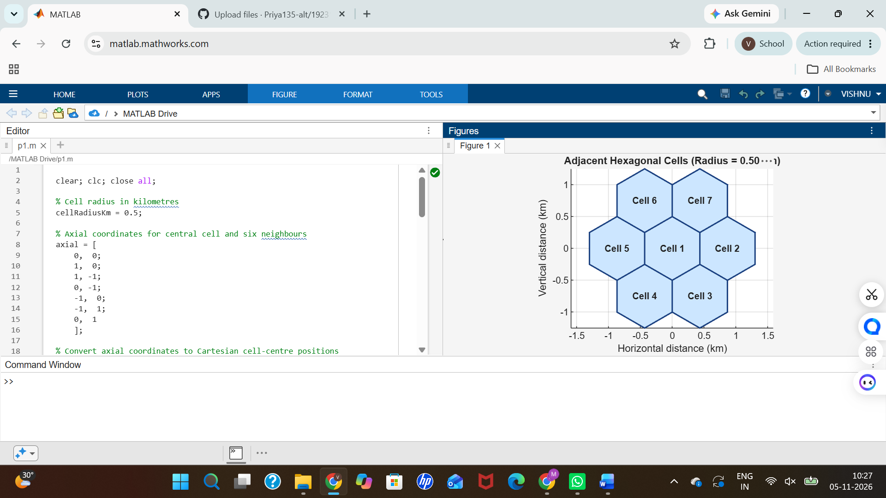
Objective 2: Estimate how cell radius affects the number of cells needed to cover a fixed area. Program

clear; clc; close all;
% Total study area in square kilometres
studyAreaKm2 = 4.0;
% Different cell radii in kilometres
cellRadiiKm = [1.00, 0.75, 0.50];
% Area of a regular hexagonal cell
cellAreaKm2 = (3 * sqrt(3) / 2) .* cellRadiiKm.^2;
% Estimate number of cells required
estimatedCells = ceil(studyAreaKm2 ./ cellAreaKm2);
% Display results in a table
results = table(cellRadiiKm', cellAreaKm2', estimatedCells', ...
'VariableNames', {'CellRadius_km', 'CellArea_km2', ...
'EstimatedNumberOfCells'});
disp('Estimated cells required:');
disp(results);
% Plot cell radius versus estimated number of cells
figure;
bar(cellRadiiKm, estimatedCells, 0.6);
xlabel('Cell radius (km)');
ylabel('Estimated number of cells');
title('Cell Radius versus Estimated Number of Cells');
grid on;
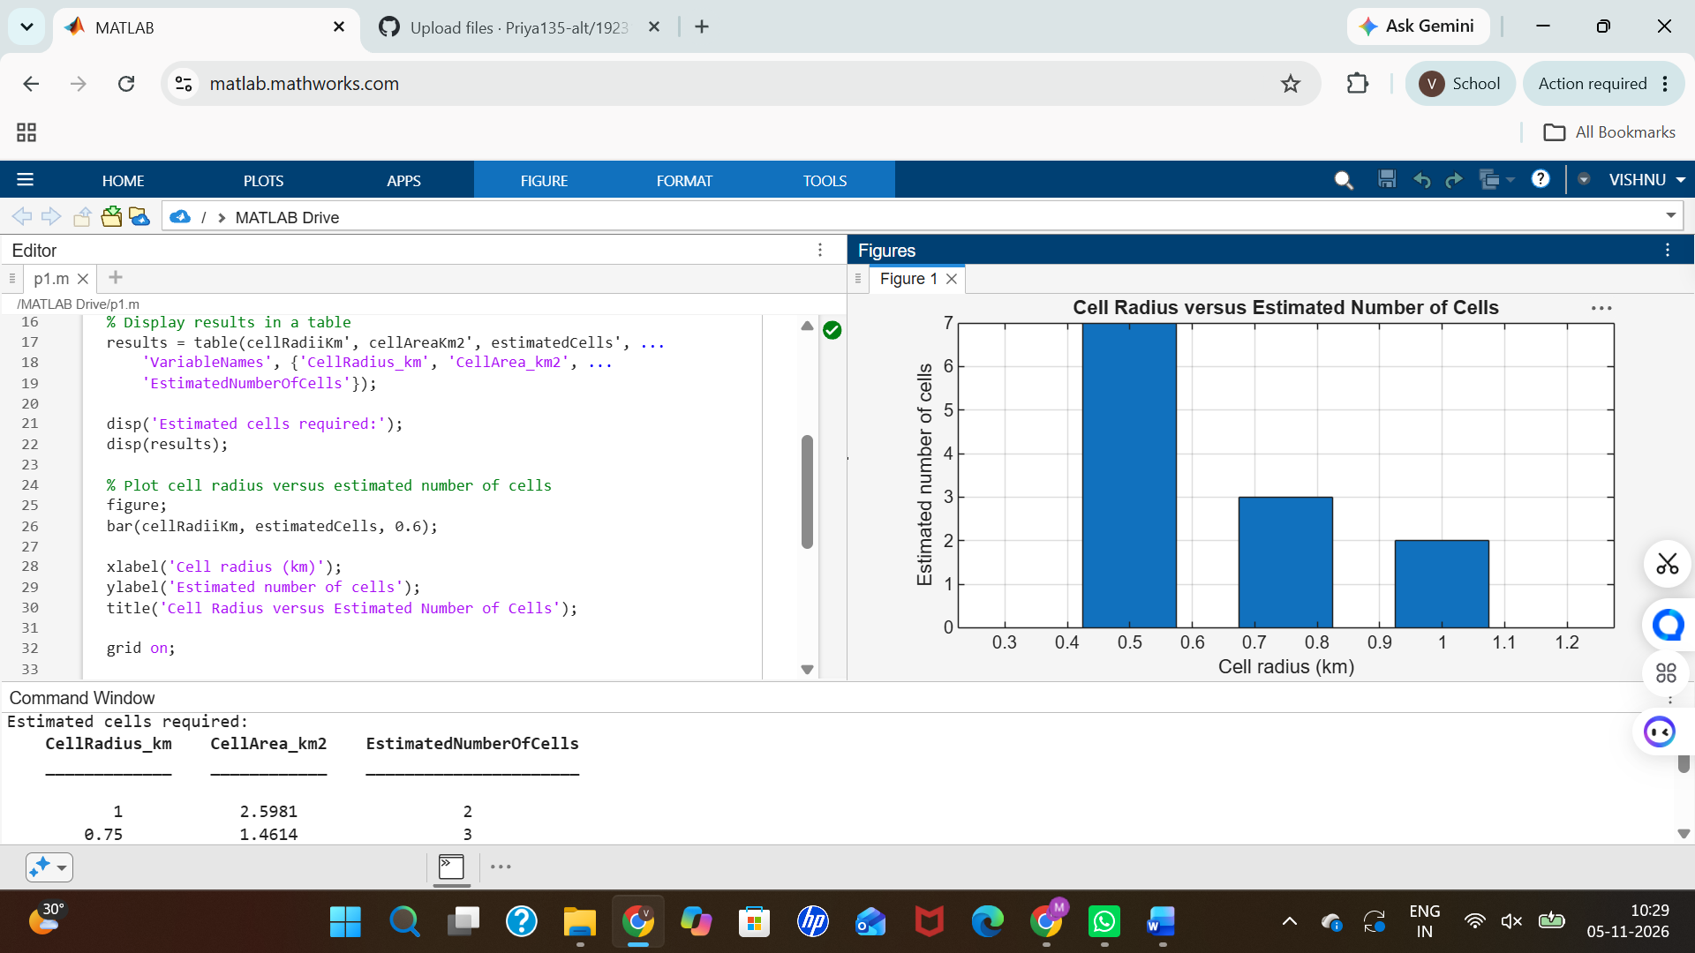
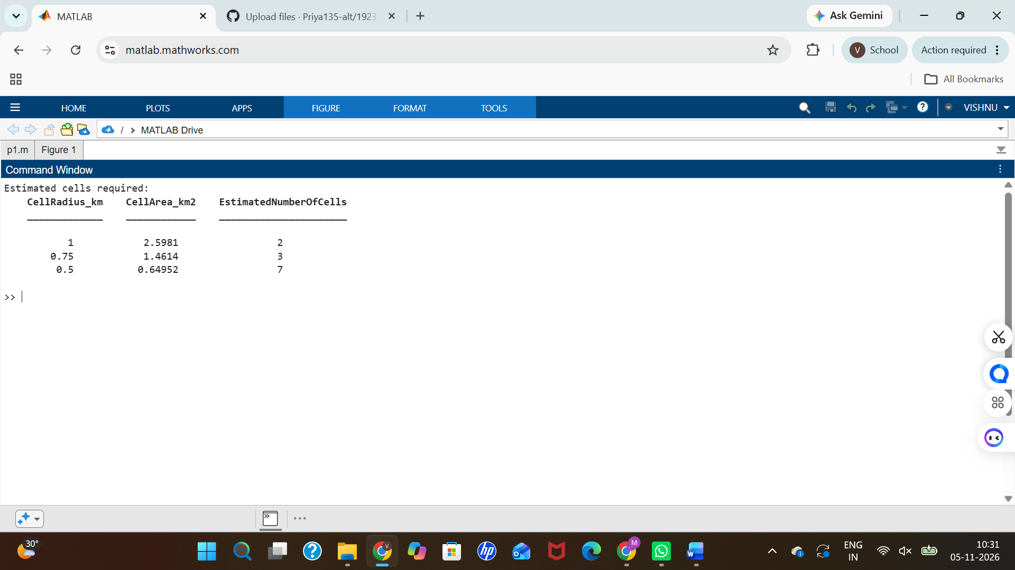
Objective 3:

clear; clc; close all;

% System parameters
studyAreaKm2 = 4.0;
userDensityPerKm2 = 30;
maxUsersPerCell = 50;

% Different cell radii
cellRadiiKm = [1.00, 0.75, 0.50];

% Calculate total user demand
totalDemand = studyAreaKm2 * userDensityPerKm2;

% Calculate hexagonal cell area and approximate cell count
cellAreaKm2 = (3 * sqrt(3) / 2) .* cellRadiiKm.^2;

estimatedCells = ceil(studyAreaKm2 ./ cellAreaKm2);

% Estimate network capacity and users served
networkCapacity = estimatedCells .* maxUsersPerCell;

usersServed = min(totalDemand, networkCapacity);

% Display results in a table
results = table(cellRadiiKm', estimatedCells', networkCapacity', ...
usersServed', ...
'VariableNames', {'CellRadius_km', 'EstimatedNumberOfCells', ...
'EstimatedNetworkCapacity', 'EstimatedUsersServed'});

disp('Estimated user capacity:');
disp(results);

% Plot network capacity and users served
figure;

bar(cellRadiiKm, [networkCapacity' usersServed'], 'grouped');
hold on;

yline(totalDemand, '--r', 'Total user demand');

xlabel('Cell radius (km)');
ylabel('Number of users');

title('Cell Size and Estimated User Capacity');

legend('Network capacity', 'Users served', 'Total demand', ...
'Location', 'northwest');

grid on;
hold off;
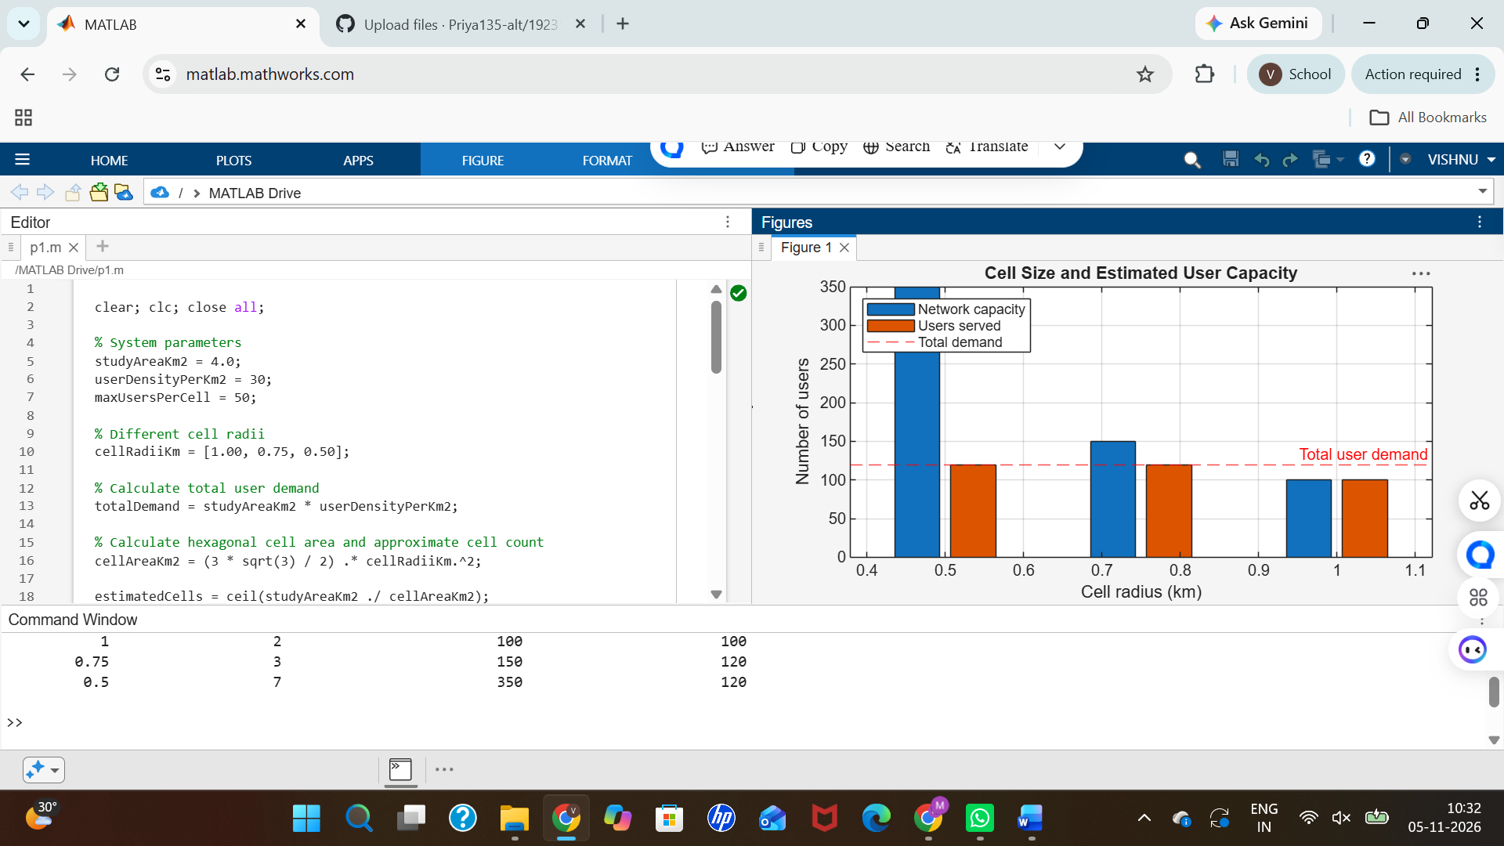
Objective 4:

clear; clc; close all;
% Cell radius
cellRadiusKm = 0.5;
radiusM = cellRadiusKm * 1000;
% Centre-to-centre spacing of adjacent hexagonal cells
separationM = sqrt(3) * radiusM;
% Mobile user moves from base station 1 towards base station 2
xMeters = linspace(0, separationM, 201);
% Distance from mobile user to each base station
minimumDistanceM = 20;
distance1M = max(abs(xMeters), minimumDistanceM);
distance2M = max(abs(xMeters - separationM), minimumDistanceM);
% Log-distance path-loss parameters
transmitPowerdBm = 30;
pathLossAt1m_dB = 40;
pathLossExponent = 3.5;
% Calculate received power from base station 1
receivedPower1dBm = transmitPowerdBm - pathLossAt1m_dB ...
- 10 * pathLossExponent .* log10(distance1M);
% Calculate received power from base station 2
receivedPower2dBm = transmitPowerdBm - pathLossAt1m_dB ...
- 10 * pathLossExponent .* log10(distance2M);
% Identify approximate handoff position
handoffIndex = find(receivedPower2dBm >= receivedPower1dBm, ...
1, 'first');
handoffPositionM = xMeters(handoffIndex);
fprintf('Estimated handoff position: %.1f m from base station 1\n', ...
handoffPositionM);
% Plot received signal strength
figure;
plot(xMeters / 1000, receivedPower1dBm, ...
'b', 'LineWidth', 1.5);
hold on;
plot(xMeters / 1000, receivedPower2dBm, ...
'r', 'LineWidth', 1.5);
xline(handoffPositionM / 1000, '--k', ...
'Estimated handoff');
xlabel('Mobile-user position (km)');
ylabel('Estimated received power (dBm)');
title('Received Signal Strength Between Adjacent Cells');
legend('Base station 1', 'Base station 2', ...
'Location', 'best');
grid on;
hold off;


